Assignment #1

21F-9513

Question #1

#include<iostream>

using namespace std;

int main()

{

int a, b, c,sum;/\*Here we are intialize three variables by taking input \*/

cout << "Enter the value of a =";

cin >> a;

cout << endl;

cout << "Enter the value of b =";

cin >> b;

cout << endl;

cout << "Enter the value of c =";

cin >> c;

cout << endl;/\*This is the condition for isosceles triangle \*/

if ((sum=a+b)>c||(sum=a+c)>b||(sum=b+c)>a)/\*Here we are checking the condition of a triangle \*/

{

cout << "It is triangle ";

cout << endl;

}

else

{

cout << "it is not Trianle ";

}

if (((a == b) && (a != c) && (b != c)) || (a == c) && ((a != b) && (b != c)) || ((b == c) && (a != c) && (a != b)))

{

cout << "Triangle is ISosceles";

cout << endl;

}

else if ((a == b) && (a == c )|| (b == c)&&(b==a))/\*This is the condition for Equilateral triangle \*/

{

cout << "Triangle is Equilateral";

cout << endl;

}

else if ((a != b) && (a != c) || ((b != c) && (b != a)))/\*This is the condition for Scalenes triangle\*/

{

cout << "Triangle is Scalenes";

cout << endl;

}

system("pause");

return 0;

}

Output

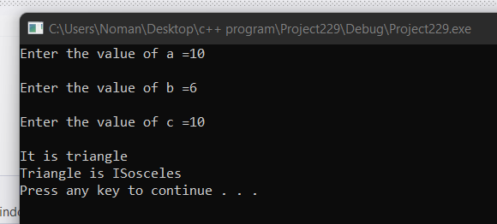

Question #4

#include<iostream>

using namespace std;

int main()

{

int num1, num2;/\*here we are taking two numbers for input \*/

cout << "Enter the first Number =";

cin >> num1;

cout << endl;

cout << "Enter the second Number =";

cin >> num2;

cout << endl;

char op; /\*This is operator for any operation which the user will perform \*/

cout << "Enter the Operator =";

cin >> op;

cout << endl;

switch (op) /\*Here we are using Switch statement for making Calculator \*/

{

case '+':

cout << "The adittion of Numbers is =" << num1 + num2;

cout << endl;

break;

case '-':

cout << " The subtraction of Numbers is = " << num1 - num2;

cout << endl;

break;

case '\*':

cout << "The Muliplication of Numbers is =" << num1\*num2;

cout << endl;

break;

case '/':

cout << "The Division of Numbers is =" << num1 / num2;

cout << endl;

break;

default:

cout << "Invalid Input";

}

system("pause");

return 0;

}

Output

